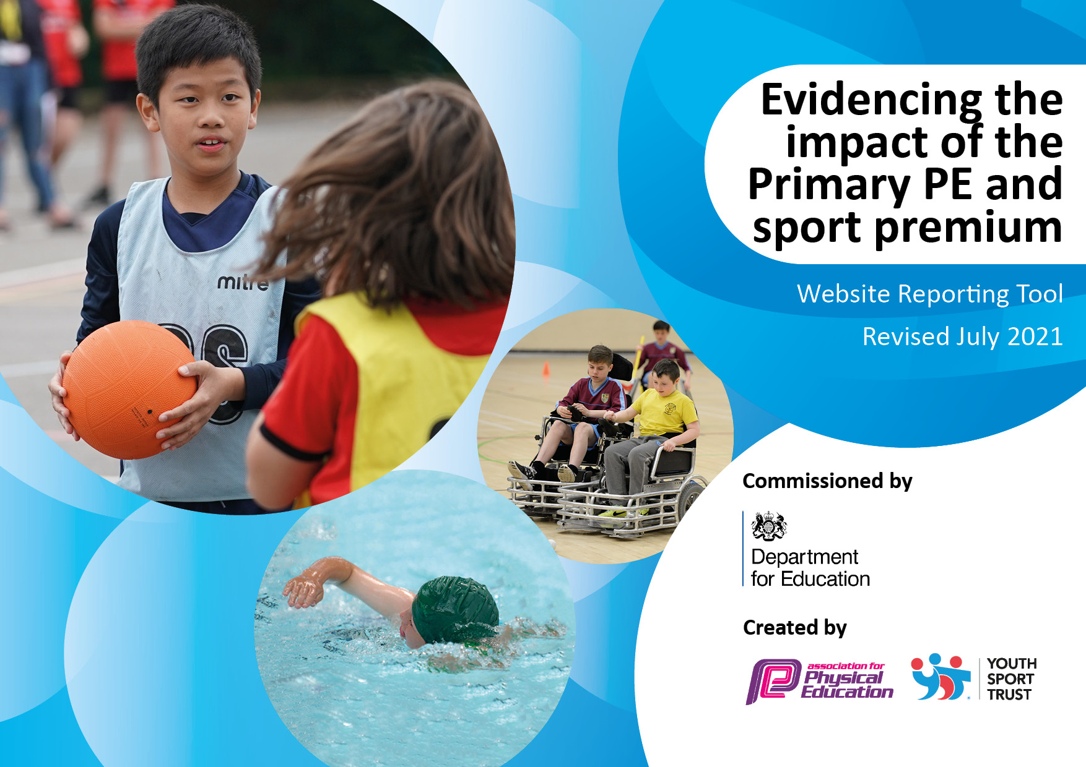
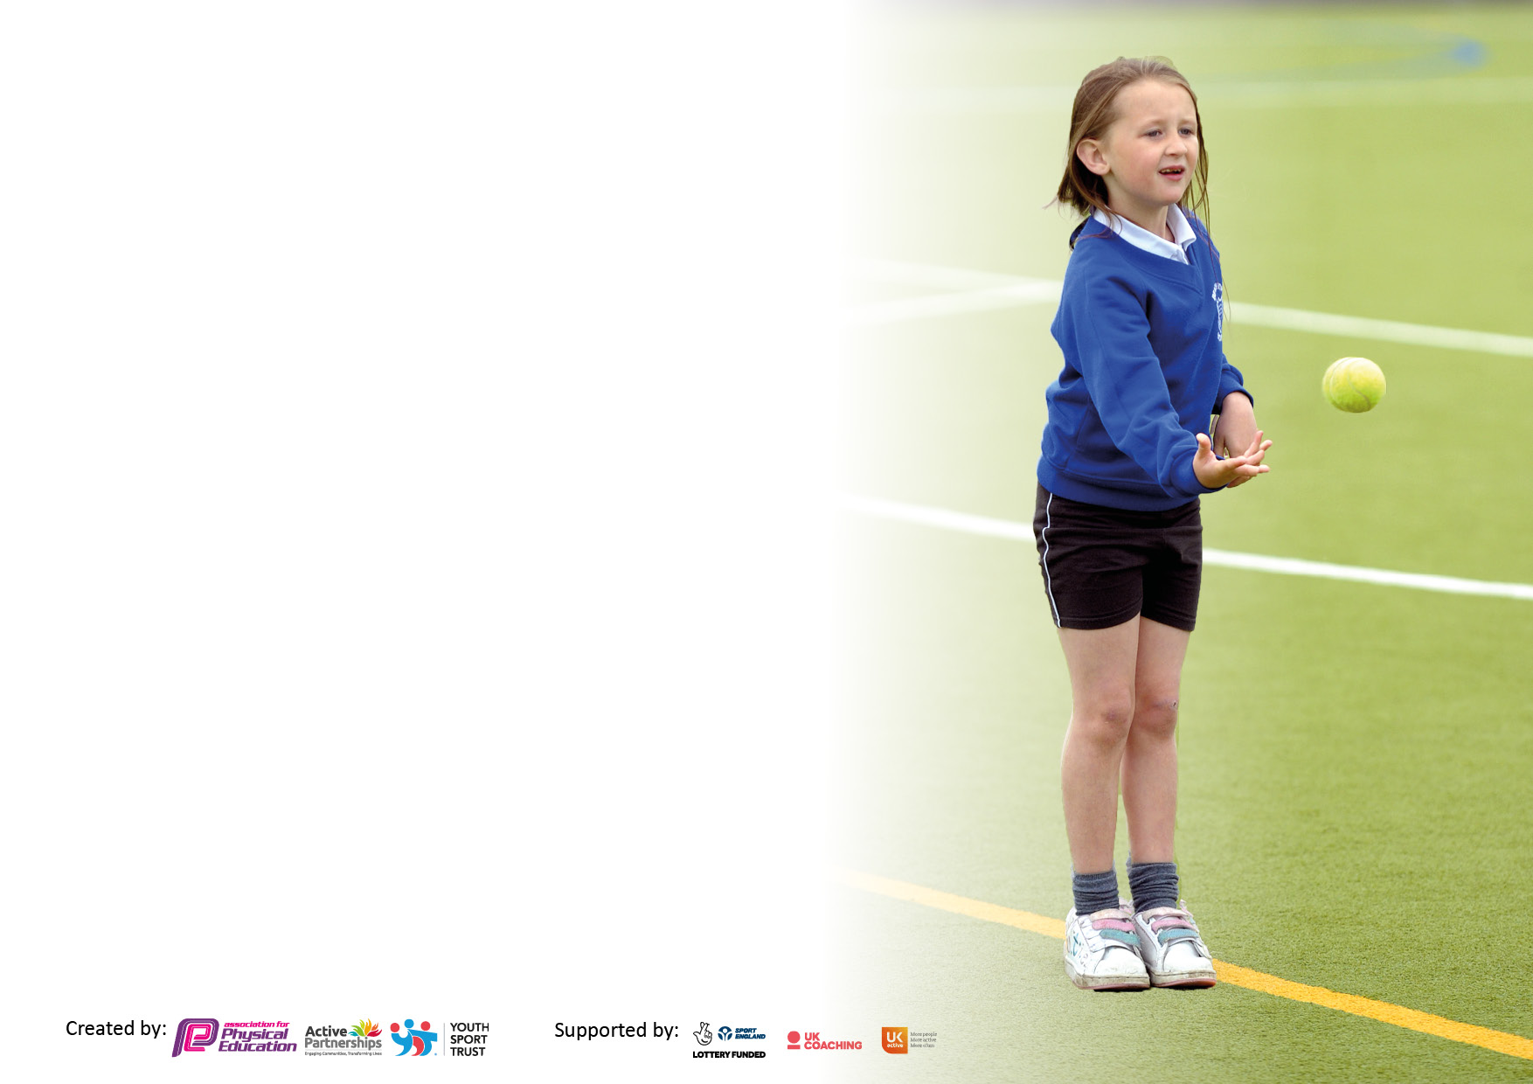

It is important that your grant is used effectively and based on school need. The Education Inspection Framework makes clear there will be a focus on ‘whether leaders and those responsible for governors all understand their respective roles and perform these in a way that enhances the effectiveness of the school’.

Under the Quality of Education Ofsted inspectors consider:
Intent - Curriculum design, coverage and appropriateness
Implementation - Curriculum delivery, Teaching (pedagogy) and Assessment
Impact - Attainment and progress

To assist schools with common transferable language this template has been developed to utilise the same three headings which should make your plans easily transferable between working documents.

Schools must use the funding to make additional and sustainable improvements to the quality of Physical Education, School Sport and Physical Activity (PESSPA) they offer. This means that you should use the Primary PE and sport premium to:

- Develop or add to the PESSPA activities that your school already offer
- Build capacity and capability within the school to ensure that improvements made now will benefit pupils joining the school in future years
- The Primary PE and sport premium should not be used to fund capital spend projects; the school’s budget should fund these.

Pleasevisitgov.ukfortherevisedDfEguidanceincludingthe5keyindicatorsacrosswhichschoolsshoulddemonstrate animprovement.Thisdocumentwillhelpyoutoreviewyourprovisionandtoreportyourspend.DfEencouragesschools to use this template as an effective way of meeting the reporting requirements of the Primary PE and sport premium.

We recommend you start by reflecting on the impact of current provision and reviewing the previous spend.

Schools are required to publish details of how they spend this funding, including any under-spend from 2019/2020, as well as on the impact it has on pupils’ PE and sport participation and attainment. All funding must be spent by 31st July 2022.

We recommend regularly updating the table and publishing it on your website throughout the year. This evidences your ongoing self-evaluation of how you are using the funding to secure maximum, sustainable impact. Final copy must be posted on your website by the end of the academic year and no later than the 31st July 2021. To see an example of how to complete the table please click HERE.

Details with regard to funding
Please complete the table below.

Total amount carried over from 2019/20 | £0
Total amount allocated for 2020/21 | £22500
How much (if any) do you intend to carry over from this total fund into 2021/22? | £0
Total amount allocated for 2021/22 | £21830
Total amount of funding for 2021/22. To be spent and reported on by 31st July 2022. | £21830
Swimming Data
Please report on your Swimming Data below.

Meeting national curriculum requirements for swimming and water safety.  N.B. Complete this section to your best ability. For example you might have practised safe self-rescue techniques on dry land which you can then transfer to the pool when school swimming restarts.  Due to exceptional circumstances priority should be given to ensuring that pupils can perform safe self rescue even if they do not fully meet the first two requirements of the NC programme of study | N/A
What percentage of your current Year 6 cohort swim competently, confidently and proficiently over a distance of at least 25 metres?  N.B. Even though your pupils may swim in another year please report on their attainment on leaving primary school at the end of the summer term 2020.  Please see note above | N/A
What percentage of your current Year 6 cohort use a range of strokes effectively [for example, front crawl, backstroke and breaststroke]?  Please see note above | N/A
What percentage of your current Year 6 cohort perform safe self-rescue in different water-based situations? | N/A
Schools can choose to use the Primary PE and sport premium to provide additional provision for swimming but this must be for activity over and above the national curriculum requirements. Have you used it in this way? | Yes/No

Action Plan and Budget Tracking
Capture your intended annual spend against the 5 key indicators. Clarify the success criteria and evidence of impact that you intend to measure to evaluate for pupils today and for the future.

Academic Year: 2021/22 | Total fund allocated: £21830 | Date Updated: 8/12/21
Key indicator 1: The engagement of all pupils in regular physical activity – Chief Medical Officers guidelines recommend that primary school pupils undertake at least 30 minutes of physical activity a day in school |  |  |  | Percentage of total allocation:
 |  |  |  | 71%
Intent | Implementation |  | Impact
Your school focus should be clear what you want the pupils to know and be able to do and about  what they need to learn and to  consolidate through practice: | Make sure your actions to achieve are linked to your intentions: | Funding allocated: | Evidence of impact: what do pupils now know and what can they now do? What has changed?: | Sustainability and suggested next steps:
Provide additional opportunities for children to participate in physical activity before school. Research shows being active in the morning can help concentration during the day. Offering this service free to families with poor attendance or who are PP can support their progress in school. | Continue to run breakfast club to encourage more pupils to be on time for school and get involved in physical activity. Addition of extra provision for year 6 during SATs week. 4 fulltime staff members are now needed to manage breakfast safely with children remaining in their year group bubbles. Breakfast club to run from 7:30am-8:40am. PE team to introduce a variety of activities from 8:00 – 8:40am Free places offered to PP children and children with poor attendance as a support mechanism. | £5304
Offer a wide range of extra-curricular activities. Children to be offered the opportunity to try new activities which may spark an interest and future participation both in and out of school. Activities to be run by external agencies to give variety alongside school staff using their personal interests and talents. | The offer of 21 clubs during  the extra-curricular offer (7 per term) covering a wide variety of experiences. These are subsidised to an affordable amount for all.  Additional spaces are available for PP children - 14 each week (2 per club) | £28 per week x 30 weeks =  £840
To engage children in physical activity during lunchtimes promoting team work and offering further opportunities to be active. | 2 lunchtime clubs to be run by PE team for 30 mins each lunchtime. children to be rotated to give everyone the opportunity to participate in a variety of sports.  In addition to adding to the 30/30 offer this will support promoting positive behaviours at lunchtime. | £2477
To set up a buddy/sports leader programme to run at lunchtimes. Promoting the profile of physical activities through peer to peer delivery. | Focus on year 6 pupils running engaging and educational physical activities at lunchtime for children in lower year groups.  Additional lunchtime equipment to be sourced/bought for the effective running of the sports leader programme | £1500
Provide new, high quality physical activity experiences for pupils. | Establish annual residential trip to an activity centre (e.g. Kingswood) who offer adventurous activities not available to our pupils elsewhere in the curriculum. This experience will be subsidised by the school. | £1500
Plan and deliver parent courses around healthy lifestyles and healthy eating alongside key curriculum areas such as Maths and English | Identify areas which parents need support with and link these together to provide a coherent set of courses for all parents to access. | £275
To utilise 1-1 support and movement breaks for year 6 SATs in order to give identified pupils a better chance of being successful. (as advised by ACTIVE Norfolk) | Identify children who would benefit from completing SATs in a 1-1 or small group environment or who would benefit from having movement breaks. Additional staff needed to provide this. 10 children identified. | £610
Provide Gross Motor skills and other physical activity skill-based intervention for children needing additional support in this area. | Identify children from PE lessons who would benefit from additional time spent on Physical activity skills. Complete a baseline of skills and then a series of sessions addressing the gaps. 7 hours and week dedicated to this provision. | £2934

Key indicator 2: The profile of PESSPA being raised across the school as a tool for whole school improvement |  |  |  | Percentage of total allocation:
 |  |  |  | 5%
Intent | Implementation |  | Impact
Your school focus should be clear what you want the pupils to know and be able to do and about  what they need to learn and to  consolidate through practice: | Make sure your actions to achieve are linked to your intentions: | Funding allocated: | Evidence of impact: what do pupils now know and what can they now do? What has changed?: | Sustainability and suggested next steps:
Raise the profile of PE and sport rewarding those children who show enthusiasm and determination. | In line with the school behaviour policy, utilise positive postcards and positive phone calls linked to effort and performance in PE sessions. | £0
Keep pupils and staff updated with current sporting news and information to raise its profile. | Create a PE display board which contains information about sport both inside and outside of school. Share successes of individuals and teams within school. Share profiles of athletes outside of school and promote as role models for our pupils. | £50
Hold a PE day for all year groups showing links to PE in other curriculum subjects. Opportunity to show the importance and profile of PE and role models within sport. | In each lesson that day, strong links to be made to PE and sport. Class budget given for this day. | £440
Start a social media campaign which encourages the school and wider community to be involved in physical activity and other areas of PE and sport. | Investigate current social media campaigns and how they have been set up. Look at the needs of our school and surrounding area in order to pitch the campaign at an appropriate level of accessibility | £500

Key indicator 3: Increased confidence, knowledge and skills of all staff in teaching PE and sport |  |  |  | Percentage of total allocation:
 |  |  |  | 5%
Intent | Implementation |  | Impact
Your school focus should be clear | Make sure your actions to | Funding | Evidence of impact: what do | Sustainability and suggested
what you want the pupils to know | achieve are linked to your | allocated: | pupils now know and what | next steps:
and be able to do and about | intentions: |  | can they now do? What has
what they need to learn and to |  |  | changed?:
consolidate through practice:
Invest in ‘PE Planning’ tool to ensure pupils receive the correct skills set and progression throughout years R-6 through high quality lessons. | Utilise PE Planning tool to map out PE units and show clear progression. Adapt sessions when necessary but stick to the skills and knowledge being covered each session. | £329
Access high quality CPD for ensure PE delivery is outstanding and meets the need of every pupil. | Sign up for the School Sports Partnership ‘pic n mix’ CPD programme. Use information from PE Deep Dive to pin point areas to sign up for. | £500
PE lead to undertake PE deep dives, regular monitoring of PE delivery and given CPD when areas of development are identified. All of these are focussed on the provision all pupils receive. | Using the school calendar of monitoring, plan in opportunities for PE monitoring and subsequent CPD. Add to PE lead action plan. Release time needed for completion of all of these activities. | £300
PE staff to complete National College courses linked to PE. Use information gained to supplement and adapt planning for the benefit of all pupils. | Ensure PE team have access to the National College. Identify courses to complete as part of the CPD package. | £0

Key indicator 4: Broader experience of a range of sports and activities offered to all pupils |  |  |  | Percentage of total allocation:
 |  |  |  | 7%
Intent | Implementation |  | Impact
Your school focus should be clear | Make sure your actions to | Funding | Evidence of impact: what do | Sustainability and suggested
what you want the pupils to know | achieve are linked to your | allocated: | pupils now know and what | next steps:
and be able to do and about | intentions: |  | can they now do? What has
what they need to learn and to |  |  | changed?:
consolidate through practice:
Offer a broader range of activities both within and outside of the curriculum in order to get more pupils involved and potentially spark a long lasting interest. | Research clubs in the local area or organisations who may be able to offer taster sessions.  Survey the children about which activities they would like to have on offer – use these ideas as a starting point. | £1500
Provide new, high quality physical activity experiences for pupils. | Establish annual residential trip to an activity centre (e.g. Kingswood) who offer adventurous activities not available to our pupils elsewhere in the curriculum. This experience will be subsidised by the school. | Spend accounted for as part of indicator 1

Key indicator 5: Increased participation in competitive sport |  |  |  | Percentage of total allocation:
 |  |  |  | 3%
Intent | Implementation |  | Impact
Your school focus should be clear | Make sure your actions to | Funding | Evidence of impact: what do | Sustainability and suggested
what you want the pupils to know | achieve are linked to your | allocated: | pupils now know and what | next steps:
and be able to do and about | intentions: |  | can they now do? What has
what they need to learn and to |  |  | changed?:
consolidate through practice:
Run Intra-school competitions to involve all pupils in competitive PE and Sport. | Classes to compete against each other in in-school and after-school competitions. Focus on inclusion for all. | £300
Provide a wider range of competitions which will appeal to both boys and girls. | Survey children to understand the sports they are keen to participate in. seek support from feeder high school or external clubs to help support with this if needed. | £0
Create opportunities for pupils to compete against other schools in the area. This will be an opportunity to not only consolidate learnt skills but to show team work and sportsmanship in a different environment. | Communicate with local schools to share vision and gauge interest. Investigate local leagues and competitions through the school sports partnership. Factor in costs for transport. | £300
Involve pupils in the Norfolk Games. | Investigate the process and opportunities offered by the Norfolk Games. Sign up for events to run both in and out of school. | £0 initially no cost.

Other Indicators identified by the school |  |  |  | Percentage of total allocation:
 |  |  |  | 44%
Intent | Implementation |  | Impact
Your school focus should be clear | Make sure your actions to | Funding | Evidence of impact: what do | Sustainability and suggested
what you want the pupils to know | achieve are linked to your | allocated: | pupils now know and what | next steps:
and be able to do and about | intentions: |  | can they now do? What has
what they need to learn and to |  |  | changed?:
consolidate through practice:
Provide swimming opportunities for children in year 5 in order to reach curriculum expectations. | Book sessions at Drayton Junior School with Swimming instructor and arrange transport accordingly. Carry out initial assessment in order to form ability groups who can focus on skills progression at each pupils level. | £1930.50
Provide Catch-up and pre-assessment opportunities for Swimming and Water safety. | Booking of temporary swimming pool on school site for 10 days. Cost in utilities alongside this.  Plan for years 4 and 6 to access the pool for curriculum purposes. Remaining time given to other year groups to add to the PE and sport activities we offer in school. | £5700 installation  £2000 utilities

Signed off by
Head Teacher:
Date:
Subject Leader:
Date:
Governor:
Date:

