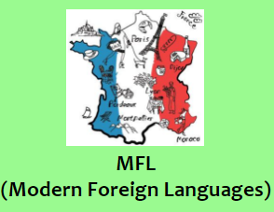 | Our pupils in EYFS and KS1 do not receive any formal languages tuition, but may listen to music from a different country as they enter and complete early morning activities and then answer the register and exchange simple greetings in the relevant language.  Children begin learning French in Ks2. We stick to the same language throughout KS2 as we feel that children will not gain the necessary breadth or depth to read and write in a modern foreign language if switching between languages.  We currently have a 3-year recovery curriculum in place to return our pupils’ skills to the desired level. The teaching of French was not assigned a high priority during the periods of remote learning and was suspended upon the return to school in March 2021 through to the summer half-term in order to focus on the wellbeing of our pupils and the reintroduction of routines. Our curriculum follows the overview of the Primary Languages Network Curriculum, but has been adapted by our Subject Lead in order to engage our pupils and to incorporate the voices of more native speakers.

